Marine FC Fan Survey, May 2025
Short summary
- The survey generated 359 responses, although this is unlikely to be fully representative of the fan base as a whole.
- There are very high levels of reported satisfaction with almost all aspects of match day provision, media and the club shop, including levels of pricing.
- Levels of satisfaction seem largely unaffected by age, fan type or ticket type.
- The greatest sources of dissatisfaction are with in-stadium bars and the stadium PA.
- Fans who are dissatisfied with in-stadium bars are often less satisfied with various other aspects of club provision.
- Members/season ticket holders and fans who see Marine as their main club attend more games, tend to rate radio commentary more highly and are significantly more likely to make purchases from the club shop.
Response levels and representativeness
The survey generated a total of 359 responses. While this is a very healthy response rate, it is important to underscore that the survey is not necessarily representative of the club’s fan base. The chart below shows the age distribution among those who completed the survey, with a clear peak among 45-54 year olds. There is presumably no means of verifying if this age distribution is statistically representative of the Marine FC fan base. However, it seems likely that an online survey of this nature would under-represent Under 18 and over 75s and my sense is that these age groups are represented to a greater degree in a typical crowd at the MTA.
Chart 1: Age Profile of Survey Respondents
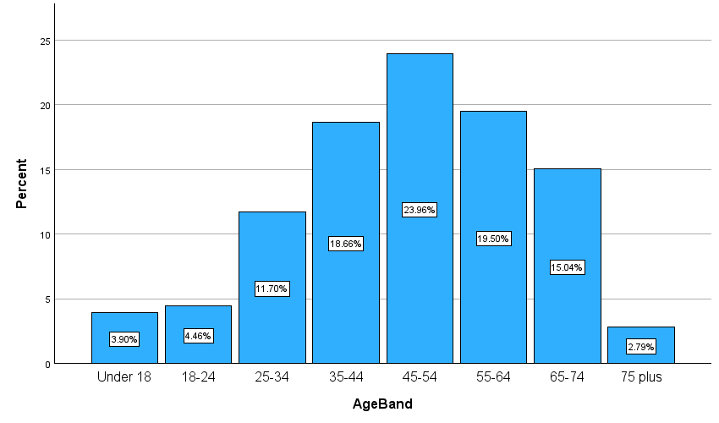
As such, all results from the survey can only be reported as the views of the fans who responded to the survey and should not be interpreted as a measure of the views of the club’s fanbase as a whole.
Supporter types and games attended
37% of respondents said Marine was the main team they follow, 42% reported that Marine is one of a few teams they follow and 20% saw Marine as their local team, which they take interest in as a result. Only 1% of responses came from away fans.
Chart 2 shows that 33% of respondents had attended over 20 Marine games this season and a further 17% had attended 16-20 games. However, the survey also generated 72 responses from fans who has attended 5 games or fewer, with this group making up 20% of the survey sample.
Chart 2: Number of Games Attended
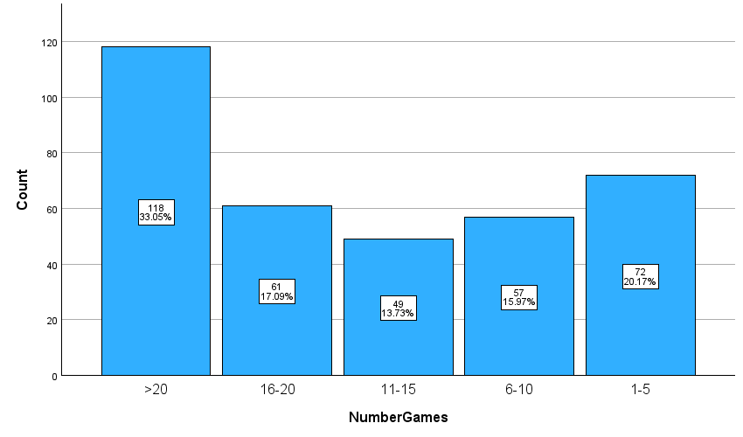
Unsurprisingly, fans who attended the most games were members and season ticket holders. 59% of season ticket holders and 53% of members had attended over 20 games, compared to just 8% who bought single tickets online and 12% who bought them in person at the ground. Similarly, 60% of fans who regard Marine as their main team had attended more than 20 games, while these attendance levels were found among only 19% of those who see Marine as one of a few clubs they support.
Of those completing the survey, 47% had attended both the South Shields and Warrington Town games. A further 19% attended just the South Shields match and 15% only the Warrington Town game. Finally, 19% of respondents had attended neither of these two matches.

Home postcodes and travel to the MTA
There were 330 unique postcodes entered. While these postcodes are widely dispersed, the great majority of fans completing the survey live close to the MTA. The most frequent postal districts were L23 (37%), L22 (17%) and L21 (5%). In total, the L23 district and those bordering it (L22, L21, L29, L38 and L30) account for 62% of respondents. Adding the next ring of postcode districts (L31, L37, L39, L20, L9) increases this figure to 75%. All postcode districts with more than 5 respondents were Liverpool postcodes other than PR8 (Ainsdale/Birkdale), with 6 respondents (1.7%).
Given the postcode distribution noted above, it is perhaps not surprising that 47% walked to the stadium. A further 31% arrived by car, either as the driver or a passenger, while 14% came by train and 7% bus. All other forms of transport were less than 2%.
Among those who drove, the great majority (80%) parked in local streets, with the remaining 20% using local car parks. Use of the MTA car park was, inevitably, very rare. The most frequent streets used for parking were College Road (n=11), Eshe Road (n=11) and Jubilee Road (n=7). I personally have difficulty believing that figure for Jubilee Road. Sixteen respondents who arrived by car could not recall the name of the road they parked in.
Arrival and Departure Times
Arriving long before the game appears to be a minority pursuit. Only 10% of respondents said they were at the MTA over 2 hours before kick-off. A clear majority of fans surveyed (65%) arrive up to 1 hour before the start of the game.
There is a similar pattern with regard to leaving the MTA. Some 42% left before or immediately after the final whistle. Only 29% reported remaining at the ground an hour after the game had finished.
Arriving early and staying on long after the game seems especially rare. Only 4% arrived two hours ahead of kick off and then left more than one hour after the final whistle. The most common arrival and departure pattern was to get to the MTA between 30 and 60 minutes ahead of kick off and to leave immediately after the final whistle (20% of respondents). Just over half of those surveyed arrived up to one hour before kick-off and left within one hour of the game ending.
Match Day Ratings
Evaluation of the match day experience was highly positive. On a five point scale, 47% rated their experience 5 out of 5 and a further 44% scored it as 4 out of 5. Less than 2% of respondents scored their match day experience as 1 or 2.
This pattern of high ratings for the match day experience is consistent across all age groups. Those who define themselves as fans of Marine as their local team are slightly less positive about the match day experience than other types of fan. There is no association with the type of ticket held by survey respondents; high levels of satisfaction are evident across all ticket types.
Chart 3: Match Day Experience
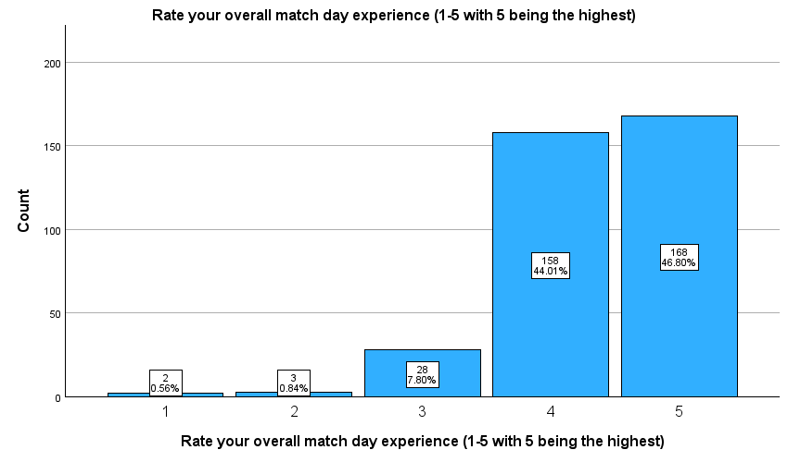
There is one identifiable factor that seems to be associated with overall evaluations of match day: in-stadium bars. As is noted below, the biggest single source of complaint identified within the survey is with the waiting times and range of choices at in-stadium bars (although it is only a minority of fans who rate this provision poorly). There is a clear, statistically significant relationship between ratings of the in-stadium bars and overall ratings for match day. The more dissatisfied respondents are with the bars, the lower they tend to score their match day experience.
Food and drink provision
The survey invited evaluations of food provision in the Bar & Bistro, food provision in the ground, drinks in the Bar & Bistro and drinks in the stadium bars. Respondents scored these from 1-5, with 5 being the highest score. The table below provides the average score for each form of provision plus the number of respondents who provided a score for that aspect of match day.
Table 1: Relative Evaluations of Food and Drink Provision (out of 5)
Provision | Average Score | Responses
Food in the Bar & Bistro | 3.8 | 181
Drinks in the Bar & Bistro | 4.2 | 288
Food in the stadium | 3.8 | 262
Drinks at stadium bars | 3.6 | 274

Stadium bars received the lowest average rating and, as noted above, were the most frequent cause for specific complaints in general feedback. A total of 44% of score for in-stadium bars were at 3 or below, while only 19% of scores for drinks in the Bar & Bistro were at this level. The following represents a sample of comments about in-stadium bars:
- “Would be nice to have Guinness on tap at the Crossender.”
- “Bar gets busy at the crossender end waiting for a pint. Could do with an extra couple of bar stands around the ground.”
- “Could do with more servers at the drinks booth at bottom”.
- “LONG QUEUES AT BAR FOR HALF TIME - CAN WE PRE ORDER ?”
- “Have more than one member of staff on the Bar round the back of the main stand or open up the other bar adjacent to it. Also, put a cider option on draught, queued up for a beer, took 20 mins and my girlfriend didn’t want anything in the end because she only wanted a cider.”
- “Getting drinks is usually very difficult and takes too long - bit of a spoiler tbh…”
- “Queuing for drinks or refreshment’s. Quality is excellent but insufficient venues both alcoholic and non alcoholic, staff overrun, very poor and lets the whole experience at Marine down.”
- “Yeah have better facilities to purchase drinks faster.”
- “The queues are the pop up bars are always too long, if you know that it's going to be a big crowd out more staff on, I waited 45 mins one game this season down the crossender end”.
- “Guinness needed inside ground. Should position a bar that serves behind main stand and car park for before and after matches (two hatches). Generally need more staff on the bars, takes too long to get served generally.”
Match day programmes
A quarter (25%) bought a programme and three-quarters (75%) did not.
Programme purchases were higher among fans who arrive 1-2 hours before kick-off (39%), among 55-64 year olds (33%) and those who see Marine as their main team (31%). Only 17% of fans who arrived less than 30 minutes before kick-off bought a programme.
There were some notable age contrasts, with 0% of 25-34 year olds reporting programme purchases, compared to 57% of under 18s (the number of respondents who were under 18 is far too low to be confident about this exact figure, but it is evident that there are contrasting attitudes to programme purchases in these age groups).
Of the 91 respondents who did buy a programme, 40% felt it was good value for money, 56% that it was about right and only 4% that it was too expensive. Similarly, 71% reported that they balance between articles and adverts was “about right”.
The most frequent suggestions for programme content were for interviews with and/or information on players, to have more content written by fans and to have a regular feature on Marine FC history or past games.

General Feedback
Fans were given the opportunity to write in general feedback about their match day experience in a free text format. A similar question was asked later in the survey about media. Since the general feedback included several points about the PA system, also covered in the media section, analysis of feedback in these two questions have been merged in some cases.
A total of 44 respondents expressed general praise for their match day experience, with a few longstanding fans noting the scale of the improvements in recent years. Two issues were clearly dominant among the more negative free-text comments: stadium bars and the quality of the PA.
Approximately 50 respondents expressed dissatisfaction with in-stadium bars, mainly with reference to the length of queues and the range of drink options. The bar at the Crosender Road end (mis-cited several times as the Crosender Way end!) was frequently cited as an issue. Several comments were about the lack of very specific drink options, such as Guinness, cider or cask ales (presumably there is simply no way of transporting some of these to pop-up bars at the other end of the ground). There were also some negative comments about staffing levels and the range of beers available in the 1894 Bar & Bistro. Further details were provided above in the section on food and drink.
28 respondents highlighted issues with the quality of the PA system. These overwhelmingly concerned difficulties hearing what is being played or said over the PA, although there were also 2 cases where the complaint was that the PA was too loud in specific sections of the ground. Further details about comments on the PA are provided in the media section.
These two issues are very likely linked to another that was quite frequently highlighted – overcrowding and pinch points in the ground, raised by 12 respondents. This was the third most cited negative comment provided as general experience. Other issues raised by 5 or more respondents were: queuing time at the snack bar (n=8), the lack of seats or unavailability of designated seats (n=8), the unavailability of chips (n=6) and the state of the toilets (n=5).
Tickets
Of those surveyed, 36% were season ticket holders, 14% were members and 41% had bought individual match tickets online. Only 1% had used the flexi-ticket option.
Ticket prices were very positively evaluated, with 39% saying they represent good value for money, 57% seeing them as “about right” and only 4% regarding them as too expensive.
Ticket prices are seen as fair across all types of ticket. Around half of members and season ticket holders regard tickets as good value for money. Only 2-3% of members, season ticket holders or purchasers of online tickets thought they were too expensive. However, 16% of those who bought their tickets in person felt ticket prices were too high.
Similarly, positive perceptions of ticket pricing are evident across all age groups, with no statistically significant variation between age categories. A higher proportion of under 18 and over 75s expressed a view that tickets prices are too expensive, but there are far too few respondents in either of these groups to be sure that this apparent difference to other age groups is a real one.
Media
As Table 2 shows, media output was rated very positively across most categories, with an average score of at least 4 out of 5 for radio commentary, social media, the scoreboard and post-match videos. The stadium PA and match day music are lowest rated overall.
Table 2: Relative Evaluations of Media Provision (out of 5, ranked highest to lowest)
Media Provision | Average Score | Responses
Radio commentary | 4.2 | 268
Match day social media | 4.2 | 332
Scoreboard | 4.2 | 351
Post-match videos | 4.1 | 328
Non-match day socials | 4.1 | 336
Podcasts | 3.9 | 231
Website | 3.8 | 350
Match day music | 3.7 | 355
Stadium PA | 3.6 | 355

There was no statistically significant variation in evaluations of media by age group other than with respect to match day music, which was more positively evaluated overall by older fans and more negatively evaluated overall by younger fans.
Radio commentary was most highly evaluated by those who see Marine as their main team and by fans who attend home games as season ticket holders or members. Other than with respect to commentary, there was no statistical association observable between any aspect of media and fan type or ticket type.
There was, however, a statistically significant association between how respondents rated in-stadium bars and how they rated the PA.
As noted above, negative comments about the stadium PA were the second largest category of complaint after the in-stadium bars. Given this, Chart 4 looks in more detail at the spread of views about this aspect of media provision on match day. As can be seen, a majority of respondents (57%) rated the PA as “excellent” of “good”. Only a small minority (17%) felt it was “poor” or “very poor”.

Chart 4: Evaluations of the Stadium PA
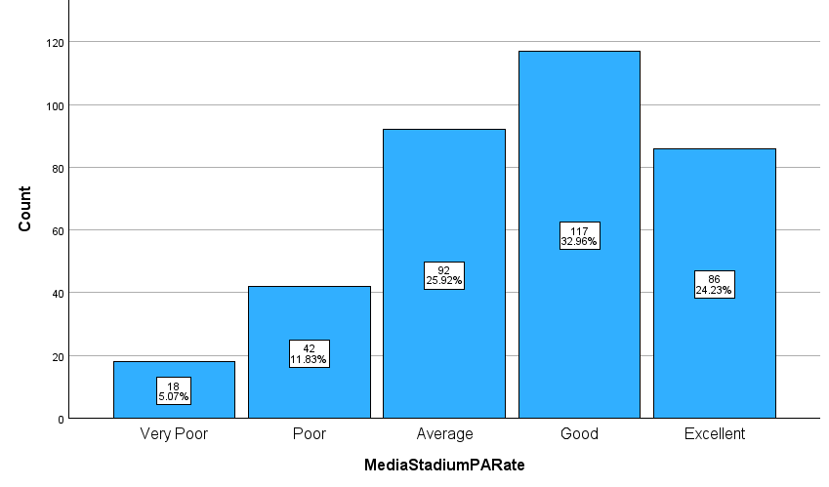
However, it is clear that this unhappy minority are very unhappy about the PA. The write-in comments about the PA overwhelmingly concerned issues with the inaudibility of announcements and music in particular parts of the ground. In addition, there was an equal balance of positive and negative comments about both match day music (7 negative, 6 positive) and about the stadium announcer personally (4 negative, 6 positive). Comments about the PA included:
- “PA system is awful”.
- “The tannoy system is awful”.
- “The sound was much improved this year, as could be heard really well all around the ground”.
- “I selected poor on the PA system as it may be good in the main stand but I usually stand at the side and it can be hard to even tell which song is playing at half time sometimes!”
- “A much louder PA would be good alongside some better music please”.
- “The announcement is too loud if you’re by the end of the jubilee side. Needs to tone it down.”
- “The music can be quite loud under the cover area.”
- “The PA system seems too loud! Perhaps it's me getting old. However, we're kept up to on relevant scores and that's good.”
- “PA is very good, very clear voice and good choice of music pre match.”
- “Loved the quizzes and themed music choices related to games. Stuart excellent pa.”
- “Match day PA and music could be more... energetic. Also the sound system at the new stand end isn't the best.”
- “We can’t understand the stadium PA at times.”
- “PA needs improving, music blares yet announcer often unintelligible”.
- “A new PA system would be most welcome to the MTA.”
- “Please play normal songs, like what you'd hear on radio 1.”
- “I think Stu will be a massive loss, he’s been superb on comms and working as the match day announcer.”
- “The quality of the sound from the PA system has improved this season but is still poor. The music choices before the games always comes across as trying to be 'too clever' Whomever the announcer is comes across as quite smug.”
- “The announcer is brilliant, great humour and great sound selections. Easily one of the highlights of the Marine set up.”
Given that music choices were also mentioned, positively and negatively, in some feedback comments, the chart below shows the distribution of respondents’ ratings of stadium music. Again, a clear majority, 63%, rated the music as either “excellent” or “good”. Those evaluating the music as either “poor” or “very poor” made up 12% of those surveyed. It is, perhaps, inevitable, that music selections cannot please all of the people all of the time.
Chart 5: Evaluations of the Stadium Music

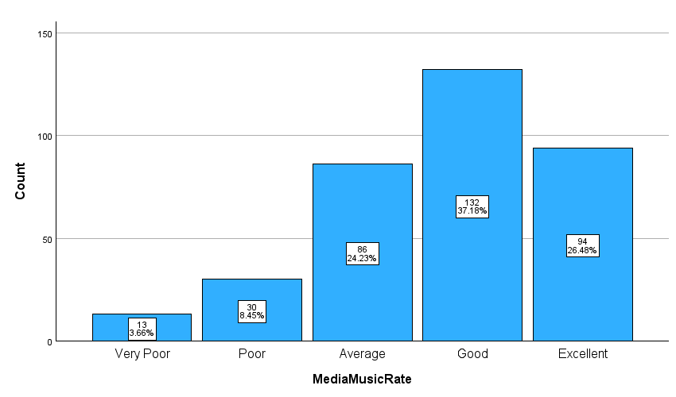
There were 16 comments about media that expressed positive sentiment in a general way, as well as 4 specific positive comments about commentary and 2 about photography. These comments included:
- “Radio Mixlr do an excellent job for away games I can’t make.”
- “Commentary is fantastic.”
- “The matchday photos have got better recently.”
Beyond the PA, other negative media comments centered on the website (n=9), scoreboard visibility (n=5), and sound quality on post-match interviews (n=4). There were 5 requests for more podcasts and 5 for more media content centered on fan engagement. There were also a handful of negative comments about social media content. The following examples provide a flavour of these comments about media:
- “On the pitch interviews are sometimes spoilt by poor sound quality, making it hard to hear what is being said. Microphones that can cope with wìndy days are needed”.
- “Post match video sound needs improvement. Either too loud or too quiet”.
- “When listening on radio(which is of a good standard) why is it when half ends it cuts off abruptly almost like there not enough money in the meter.”
- Website content is good, but it doesn't seem joined up e.g. you read an article and the links below it are years old, not the most recent news items.
- “Social media is hit and miss, the website isn't kept up to date, presence online could be higher.”
- “I'm not a technical expert but could the quality of the match day highlights be better, the picture quality and overall production doesn't seem as good as other clubs in the same division. Obviously I do understand that most of the people are volunteers.”
- “Social media some of the graphics look awful whilst some look really professional - not sure if it’s different people but is really inconsistent.”
- “Photos and videos of the game are great and look really professional”.
- “Better podcasts would be useful, production levels could be also be improved vastly.”
- “Media team could include more views of supporters rather than just the club.”
Club Shop
Two-thirds of respondents had made a purchase from the club shop (66%). There was no strong association between age and use of the club shop, although the data suggests that younger fans may be more likely than other age groups to make purchases (or have purchases made for them, in the case of under 18). There is a very strong association between supporter type/ticket type and shop purchases. Among members, season ticket holders and those who see Marine as their main team, 8 out of 10 have bought items from the club shop.
Among the 222 fans who had made a purchase from the club shop, the average rating on the 5-point scale was 4.2. There is no association between ratings for the club shop and age, fan type or ticket type – levels of satisfaction are broadly consistent across all these categories. The one variable that shows a strong association with ratings for the club shop is, again, the level of satisfaction with in-stadium bars.
Fewer respondents had bought items from the online shop, with only 139 providing a rating for this, with an average of 3.7 out of 5.
Feedback about the club shop included 6 comments praising the offer and/or noting significant improvement, 7 requests for longer opening and 12 negative comments about stock availability, quality or range – all centered on replica kit and clothing. There were also 3 comments about the shop being too small and 4 complaints about delivery times from the online shop. There were 10 respondents who made specific suggestions for other products to stock, ranging from blankets to golfing umbrellas, but no item was mentioned twice. As such, there was no obvious item that would be in high demand, if stocked.
Stuart Wilks-Heeg, 9 May 2025

Given the suboptimal location of speakers, some need to be turned up to a very high level to compensate for gaps in coverage in other parts of the ground. Fans sat or stood near these speakers will inevitably find them very loud!
It should be noted that there were multiple games this season when speakers did not work at the Crosender Road end or along parts of the Jubilee Road side of the ground because speaker cables had been accidentally cut by contractors. In addition, larger crowds and greater crowd noise at the Crosender Road end, following the addition of the new stand, is likely to drown out the PA in that part of the ground, where there are only two, poorly positioned speakers.

